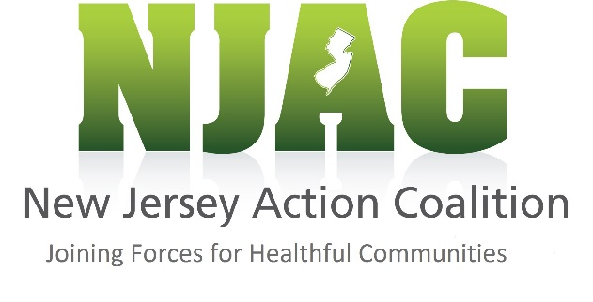

Date: May 2017

New Jersey Action Coalition Calling All
Passionate Nurse Volunteers!
Program Description: The New Jersey Action Coalition (NJAC) has made a commitment to lead an initiative where embedding and engaging nurses within existing community projects will promote an outcome of healthier communities, well-being and equity for New Jersey citizens.

Communicate/Work with: NJAC Coaches, NJAC Staff & Non-Profit Organizations

Objective:
Nurse volunteers will have the opportunity to help improve the health of their community by engaging in the NJAC Culture of Health Initiative of Joining Forces for Healthful Communities. Our goal is to match volunteer nurses to a variety of existing community projects throughout the state of NJ.

Requirements:
- Should be a Nurse
- Willing to participate in professional education (webinars or in-person)
- Be available by email/phone
- Have some volunteer and community work experience
- Be able to commit necessary time
- Be a good team player

What is the role of a nurse volunteer?
- Engaging in existing projects in their own communities
- Contributing time, expertise and their passion to their community and organizational projects with the ultimate goal to impact health
- Collaborate with nurse coaches in their county and help remove existing barriers that impede healthy living
Why Participate in this Initiative?
- Boost your career with community outreach involvement and specialized education that you will be provided
- Build a sense of pride in contributing your talents to your community
- Foster leadership development
- Open doors to other opportunities

For more information on how to get involved, please visit our website at www.njactioncoalition.org and complete your profile today!

Contact: Jennifer Polakowski, Community Liaison - jpolakowski@njha.com - (609)-275-4045

